Music
We will be listening to and learning ‘The Fresh Prince of Bel Air, composed by Quincy Jones. We will be using the notes D, G & A.
PHSE
In PSHE, we will be learning about health and wellbeing – keeping safe including first aid
Physical Education (PE)
Football – In this unit, we will develop our skills of attacking and defensive principles in invasion games.
Rounders – In this unit, we will develop our understanding of fielding and striking techniques.

History-The Maya
In history, we will be learning about the ancient Mayans, looking at their daily life, achievements, structure of society and their decline.
Modern Foreign Language (French)
We will be learning how to use basic greetings, as well as asking and answering questions.
Design Technology
Frame structures
In this unit, we will be applying our knowledge of how to strengthen a structure and we will also be evaluating existing products.

Science- Properties of materials
We will be learning about the properties of materials, including how to compare and group materials based on their properties. We will be able to give examples of reversible and non-reversible changes to materials.
English
Outcomes will include writing information labels, short explanations, landing logs and a news report. Children will also develop comprehension skills using a range of texts and learn spellings and spelling rules.

Religious Education
Our focus is: Salvation
Our question is:
What did Jesus do to save human beings?
Maths
This half term we will be focusing on measuring – perimeter and area. We will also be learning about data and how to read and interpret graphs and tables.
Year 5 Spring 2
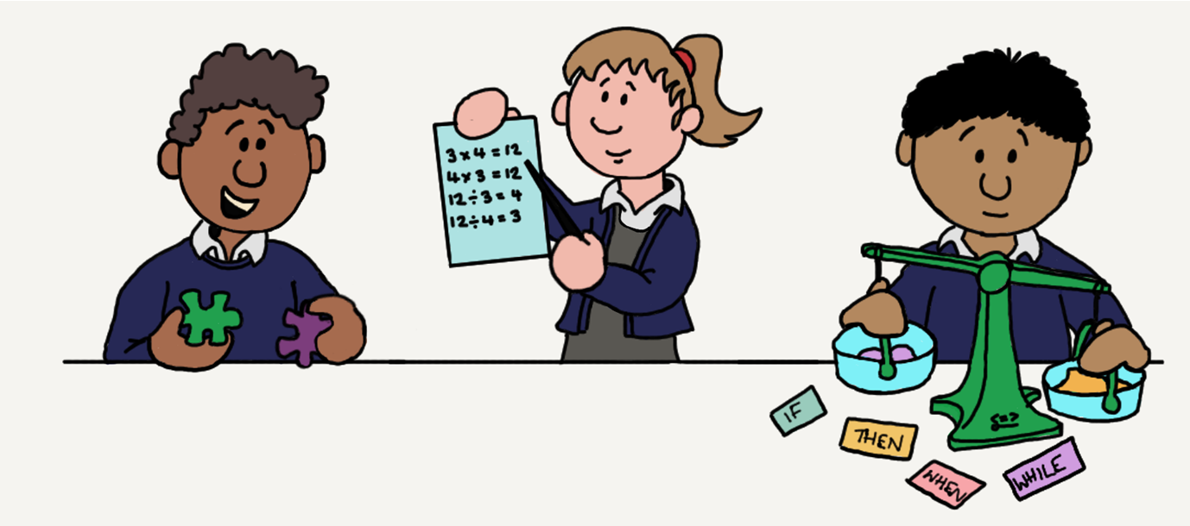
‘Enriching Lives’ by connecting learning The Maya

Maya workshop

